While the creative freedom of graphic design might seem alluring, the profession comes with its own set of hurdles. One significant challenge is managing client expectations. Translating a client's sometimes vague vision into a tangible design can be a delicate dance. Imagine a client requesting a logo that's "sophisticated yet playful," leaving the designer to decipher this seemingly contradictory brief. The key lies in clear communication, asking the right questions, and skillfully guiding the client towards a design that resonates with both their vision and the project's goals.

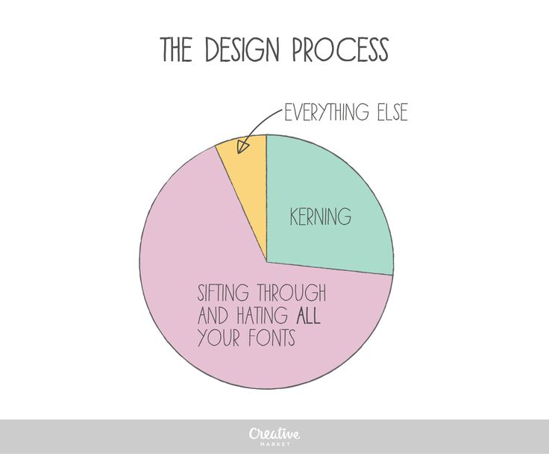

Another ongoing battle is staying ahead of the curve. The design landscape is constantly evolving, with new trends and technologies emerging all the time. Keeping up with the latest software advancements, design styles, and user preferences requires dedication and a thirst for knowledge. Imagine a designer who hasn't embraced responsive web design principles, leaving their websites clunky and unusable on mobile devices. The ability to adapt and learn is crucial for designers to stay competitive and deliver projects that are not just aesthetically pleasing, but also relevant and functional in today's digital age.

Finally, there's the ever-present battle against creative burnout. The pressure to constantly churn out fresh ideas can be a real drain on inspiration. Imagine a designer facing back-to-back deadlines for projects with vastly different aesthetics. Finding ways to manage workload, prioritize tasks, and incorporate breaks for creative rejuvenation is essential. Many designers find solace in personal projects, allowing them to explore their own artistic voice and reignite their passion for the craft.